Press Kit

- Biographies

  - Short bio (901 characters incl. spaces)
At 26, French mezzo-soprano Léontine Maridat-Zimmerlin captivates with a radiant stage presence and a rare gift for phrasing. She was named Révélation Artiste Lyrique at the 2026 Victoires de la Musique Classique Awards. Trained at the Paris and Lyon Conservatoires (CNSMD), then at the Opéra-Comique’s Académie Favart, she is equally at home in opera and in art song. She has already portrayed Oreste, the Second Lady and Cherubino, and has won several international competitions. In the 2025–26 season, she will be heard as Diana at the Opéra-Comique, Stéphano at the Théâtre des Champs-Élysées and Mercedes at the Capitole de Toulouse. She performs regularly in recital, notably at the Château de Parentignat, the Teatro de la Maestranza, and Les Invalides. An ADAMI 2025 artist and a member of the Académie Jaroussky, she is represented by the Do Opéra agency and supported by the SIAA Foundation.

  - Medium bio (2,309 characters incl. spaces)
At 26, French mezzo-soprano Léontine Maridat-Zimmerlin captivates audiences with a radiant stage presence and a rare gift for phrasing. She has been named “Révélation, lyrical artist” at the 2026 Victoires de la Musique Classique. After eleven years with the Maîtrise de Paris and studies at La Sorbonne, she refined her artistry at the Conservatoire National Supérieur de Lyon before joining the CNSMD de Paris, where she earned her Master’s degree in 2025. Competitions quickly recognized her distinctive personality: three prizes at the Concours International de Mélodie de Gordes (2022), then in Paris the Georges Enesco Competition (2023) awarded her the Génération Opéra Prize and the Grand Prize for Contemporary Music, along with an invitation to the Gala des Jeunes Ambassadeurs Lyriques in Montreal. A few weeks later, she also received the French Repertoire Prize at the Jeunes Espoirs Opéra Raymond Duffaut competition.
On stage, she has portrayed Oreste in La Belle Hélène, the Second Lady in The Magic Flute, and in 2025, Cherubino in a production directed by Mariame Clément, co-produced with the Philharmonie de Paris. That same year at the Opéra-Comique, she enjoyed the transformations of Gluck’s L’Île de Merlin (La Candeur, Hippocratine, La Notaire). Deeply drawn to chamber music, Léontine appeared in 2025 at the Amphitheatre of the Seville Opera House in a recital of English art songs with Carmen Martinez-Pierret (piano) and Israel Fausto-Martinez (cello). In addition, her duo with pianist Louis Dechambre won the Duo Prize at the International Competition of Clermont-Ferrand. A few months later, she also won, with pianist Ayano Kamei, the Grand Prize for voice–piano duo at the International Nadia and Lili Boulanger Competition.
The 2024–2025 season welcomed her to the Académie Favart at the Opéra-Comique (under Louis Langrée and Mathieu Pordoy). In 2025–26: Diane in Iphigénie en Tauride (Opéra-Comique), Stéphano in Roméo et Juliette (Théâtre des Champs-Élysées) and Mercédès in Carmen (Capitole de Toulouse), as well as recitals in Basel, Clermont-Ferrand, at the Théâtre Montansier, and more. Selected for Génération Opéra 2025–2026, named an ADAMI 2025 artist, and a member of the Académie Jaroussky, Léontine is represented by Do Opéra and supported by the SIAA Foundation.

  - Long bio (4,012 characters incl. spaces)
Named “Révélation, lyrical artist” at the 2026 Victoires de la Musique Classique, Léontine Maridat-Zimmerlin is a 26-year-old French mezzo-soprano, represented by Do Opéra since 2024. After beginning with cello and dance, she spent eleven years at the Maîtrise and the CRR of Paris. She earned a Bachelor’s degree in musicology from La Sorbonne in 2021. That same year she joined the Conservatoire National Supérieur de Lyon, studying with Sophie Marin-Degor, Hélène Lucas, and Nobuyoshi Shima. In 2023 she obtained the DNSPM with highest honours and continued her training in a Master’s programme at the Conservatoire National Supérieur de Paris, graduating in 2025.

Passionate about art song, she stood out in 2022 at the Concours International de Mélodie de Gordes, where she won three prizes including the Karine Deshayes Special Prize. In 2023 she was awarded prizes at the Georges Enesco Competition in Paris, receiving the Génération Opéra Prize, the Grand Prize for Contemporary Music, and an invitation to the Gala des Jeunes Ambassadeurs Lyriques in Montreal. A few weeks later she was also awarded the French Repertoire Prize at the Jeunes Espoirs Opéra Raymond Duffaut competition.

During her studies, Léontine had the opportunity to perform several roles in conservatoire productions, notably the vain Oreste in La Belle Hélène and the madcap Zweite Dame in The Magic Flute at the CNSMDL, both staged by Bernard Rozet. In 2025 she played a mischievous Cherubino in a CNSMDP production directed by Mariame Clément, co-produced with the Philharmonie de Paris. That same year she also appeared in three roles—La Candeur, Hippocratine, and La Notaire—in Gluck’s L’Île de Merlin ou Le monde renversé, staged by Myriam Marzouki at the Opéra-Comique. Her commitment to opera has been enriched by the mentorship of Clémentine Margaine through the Fonds Tutti programme, and by numerous masterclasses, notably with Karine Deshayes (Boissettes en Scène), as well as Stéphane Degout, Simon O’Neill, Cyril Dubois, Raphaël Pichon, Sabine Devieilhe, Emmanuelle de Negri, Laurence Equilbey, and Louis Langrée.

Strongly attached to the chamber-music repertoire, she performed in 2025 at the Amphitheatre of the Seville Opera House in a recital of English art songs with Carmen Martinez-Pierret (piano) and Israel Fausto-Martinez (cello). In May 2025, her duo with pianist Louis Dechambre won the Duo Prize at the International Competition of Clermont-Ferrand. A few months later, she also won with pianist Ayano Kamei the Prince Rainier III of Monaco Grand Prize for voice–piano duo at the International Nadia and Lili Boulanger Competition. She maintains a sincere friendship with both musicians and is deeply committed to these partnerships, built on mutual trust and a shared passion for the chamber repertoire.

For the 2024–2025 season, Léontine joined the Académie Favart at the Opéra-Comique under the artistic direction of Louis Langrée and Mathieu Pordoy—an experience that enabled her to sing alongside Stéphane Degout in an onstage recital and to take part fully in the daily life of an opera house. There she also developed a particular affection for outreach work with children. She completed her Master’s degree with highest honours, unanimously, at the Conservatoire National Supérieur de Paris, studying with Frédéric Gindraux.

The current season brings several major debuts: Diane in Iphigénie en Tauride at the Opéra-Comique, Stéphano in Roméo et Juliette at the Théâtre des Champs-Élysées, Marcelina in Le nozze di Figaro in Pistoia (Italy), Tisbe in Rameau’s Pygmalion with Les Talens Lyriques, and Mercédès in Carmen at the Capitole de Toulouse. Several recitals are planned in Basel, at the Opéra de Clermont-Ferrand, at the Musée de l’Armée (Les Invalides), and in various summer festivals. She has also been selected for the new Génération Opéra 2025–2026 cohort, announced as an ADAMI 2025 artist, and joined the Académie Jaroussky in September 2025. Léontine is supported by the SIAA Foundation.

- Contact
  - Agency: Do opéra
Website: https://do-opera.com/
Paris address: 4 rue Copernic, 75116 Paris, France
New York address: 33 Bond Street - Suite 1512, Brooklyn NY 11201, USA
Tel : +33 660 551 667 Email : philippe@do-opera.com
  - Artist:
Website : https://leontine-maridat-zimmerlin.com/
Instagram : https://www.instagram.com/leontine_maridat_zimmerlin/
YouTube : https://www.youtube.com/@leontinemaridatzimmerlin
Facebook : https://www.facebook.com/people/L%C3%A9ontine-Maridat-Zimmerlin/61585442701292/

- Artist profile
  - Identity & voice
- Name: Léontine Maridat-Zimmerlin
- Nationality: French
- Voice type: Mezzo-soprano
- Age: 26 (born October 1999)

  - Training
- Maîtrise de Paris (middle school → high school).
- CRR de Paris – Advanced Department for Young Singers (DEM in voice, highest honors). link .
- Bachelor’s degree in Musicology – Sorbonne (Paris-IV/Paris-Sorbonne): 2021 link.
- CNSMD Lyon, DNSPM with highest honors (2023) – teachers: Sophie Marin-Degor, Hélène Lucas, Nobuyoshi Shima. link
- CNSMD Paris (Master’s, highest honors unanimously, 2025) – teacher: Frédéric Gindraux. link
  - Professional support, academies & sponsorship
- Agency : Do Opéra (since 2024) link

- Académie Favart – selected in 2024 (Opéra-Comique). link
- Académie Jaroussky – entry in September 2025. link

- Fonds Tutti – 2024 cohort artist. link
- Talents Adami Classique – 2025-2026 artist. link
- Génération Opéra – 2025–2026 cohort artist. link

- SIAA Foundation : Support since 2025. link

  - Competitions & distinctions
- Concours international de mélodie (Gordes, 2022) : won three prizes including the Karine Deshayes Special Prize. link
- Concours Georges Enesco (Paris, 2022) : Génération Opéra Prize and Grand Prize for Contemporary Music. link
- Concours Jeunes Espoirs Opéra Raymond Duffaut (Paris, 2023) : Prize for French Repertoire. link
- Jeunes Ambassadeurs Lyriques de Montréal (2024). link
- Concours international de Clermont-Ferrand (2025) : Duo Prize with pianist Louis Dechambre. link
- Concours International de chant-piano Nadia et Lili Boulanger (2025): Voice and Piano Duo Grand Prize with pianist Ayano Kamei. lien
- Named “Révélation, lyrical artist” at the Victoires de la Musique Classique (2026). link

  - Stage career & notable roles
- Orestes (La Belle Hélène, 2022): CNSMDL, staging by Bernard Rozet.
- Zweite Dame (Die Zauberflöte, 2023): CNSMDL, staging by Bernard Rozet.
- Cherubino (Le nozze di Figaro, 2025): CNSMDP, staging by Mariame Clément.
- La Candeur, Hippocratine & La Notaire (L’Île de Merlin ou Le monde renversé, 2025): Opéra-Comique, staging by Myriam Marzouki.

- Recital of English songs (Seville Opera – Spain, 2025): with Carmen Martinez-Pierret (piano) and Israel Fausto-Martinez (cello).
- Gala Concert “Young International Opera Stars” (Dzintari Concert Hall, Jūrmala – Latvia): with the SIAA Foundation.

  - Recent & upcoming schedule
- Iphigénie en Tauride (Théâtre National de l'Opéra-Comique - Paris) : role debut as Diane/Second Priestess – November 2025. link
- Roméo et Juliette - C. Gounod (Théâtre des Champs Elysées - Paris): role debuts as Stéphano, Gertrude – February 2026. link
- Carmen - G. Bizet (Capitole de Toulouse) : role debut as Mercedes (all casts) – July 2026. link

- Press
“The undisputed star of the evening was the voice of young Léontine Maridat-Zimmerlin, a lyric mezzo-soprano with a luminous timbre and effortless top notes, whose freshness of tone and excellent diction make her an ideal interpreter of this repertoire.”
Mondoclassico – Seville concert – February 2025

“Léontine Maridat is an adorable Cherubino.”
Opéra Magazine — Les Noces de Figaro (CNSMDP) — May 2025

“If a prize were to be awarded at the end of this audition, it would probably go to Léontine Maridat-Zimmerlin (add her to your Olyrix favorites!). Very at ease in her rapport with the audience, she imbues her interpretation with her evidently sparkling personality. Her face is expressive and every note has meaning, allowing her to hold the audience’s attention. Her silvery-timbred voice is incisive and well produced, demonstrating technical qualities that add to her theatrical talent.”
Olyrix — Génération Opéra — December 2024

“Mezzo Léontine Maridat-Zimmerlin delivers Rosina’s aria from Rossini’s The Barber of Seville with great assurance. One is struck first and foremost by a warm, powerful voice and an undeniable presence. The intentions and impulses she brings to each phrase are quite admirable.”
ResMusica — Adami Concert — July 2025

“Léontine Maridat-Zimmerlin makes her mark with an intense Idamante (Idomeneo), before bringing the house down with a Helen (La Belle Hélène) as sumptuous in timbre as it is even throughout the voice—and always admirably intelligible.”
Opéra Magazine — 7th “Raymond Duffaut” Competition — November 2023

“Léontine Maridat made a strong impression at the Génération Opéra auditions a few months ago. She now confirms the talent she revealed then, crafting a delightfully mischievous Cherubino whose stage portrayal nourishes the singing. She is aided in this by a supple, intense voice—well produced, with a brilliant timbre.”
Olyrix — Le nozze di Figaro (CNSMDP) — March 2025

- Photo Gallery
1.Portait
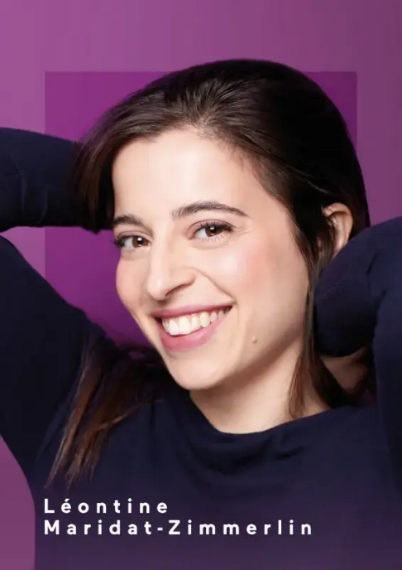
Royalty-free; photo credit: Pascal Ito
High-resolution image link

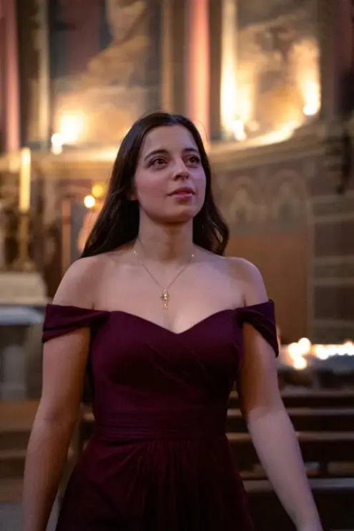

Royalty-free; photo credit: Allan Rec
High-resolution image link

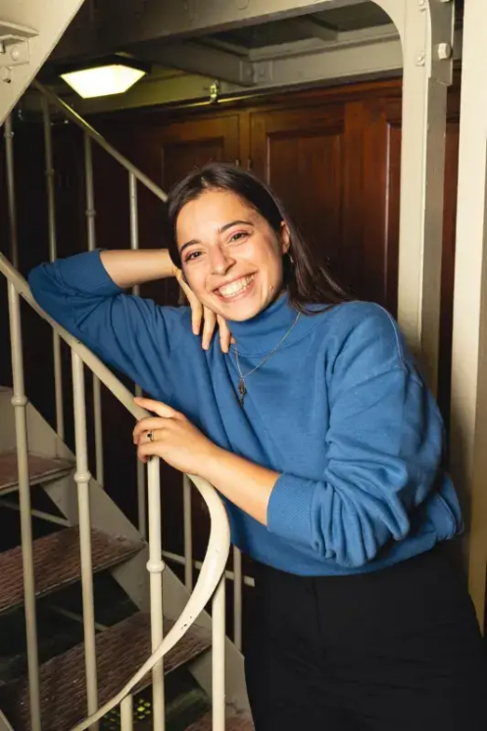

Royalty-free; photo credit: Yann Salaün
High-resolution image link

2.On stage
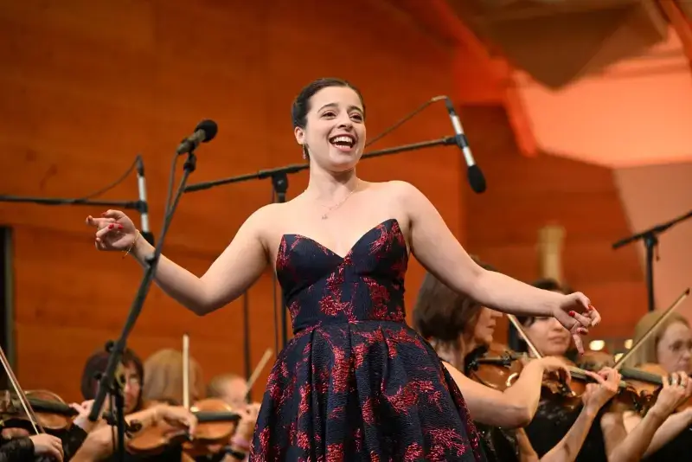

Royalty-free; photo credit: SIAA Foundation
High-resolution image link
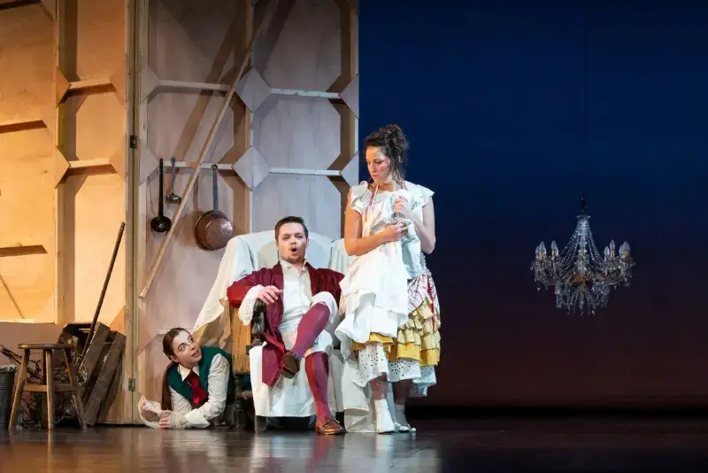
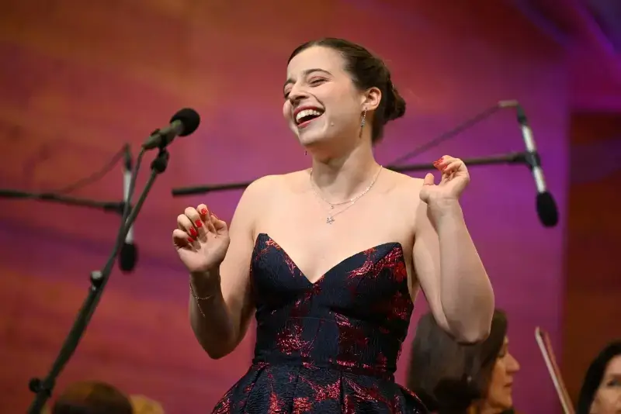
Royalty-free; photo credit: SIAA Foundation
High-resolution image link
Royalty-free; photo credit: Ferrante-Ferranti
High-resolution image link

